Mock Test Q4 2025-2026  Question 1: Database Setup (10d)  Dạng bài: Khởi tạo Database, Nạp dữ liệu từ file SQL có sẵn và kiểm tra trạng thái bảng. (Create a PostgreSQL database using your full name in lowercase, without spaces or Vietnamese diacritics. Connect to it and execute MIS443_Finance_PostgreSQL.sql. Confirm that the customers, branches, accounts, and transactions tables are available in the public schema.)  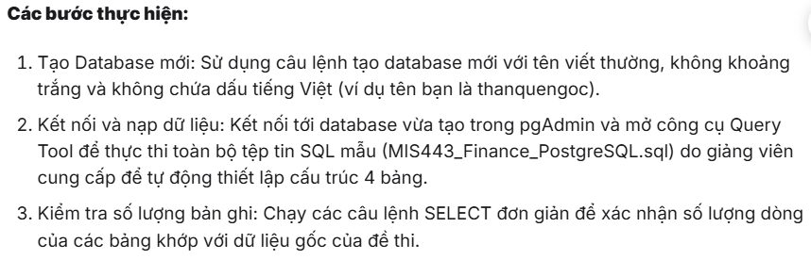  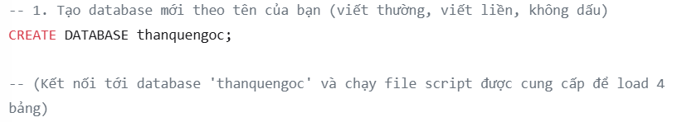  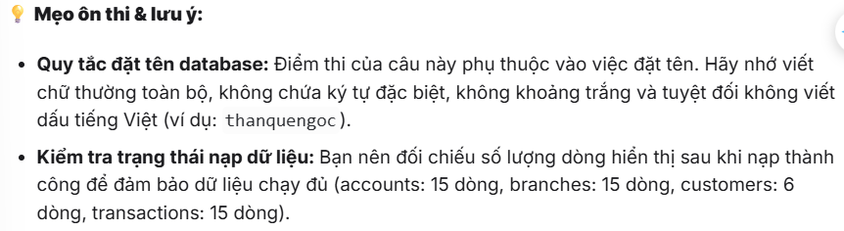  Question 2: Customer and Account Overview (10d)  Dạng bài: Lọc dữ liệu chuỗi (String Filtering) kết hợp Ghép chuỗi (Concatenation) và Sử dụng hàm đếm cơ bản (COUNT).  (a) The Customer Service Manager needs a contact list of customers living in New York. Display customer_id, the customer’s full name as full_name, and city. Sort by customer_id. (5 marks)  (b) Management needs to confirm the size of the account portfolio. Calculate the total number of accounts and name the result total_accounts. (5 marks)  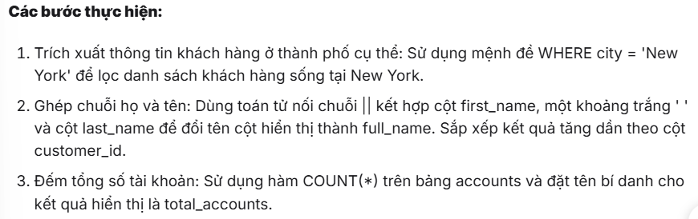 | 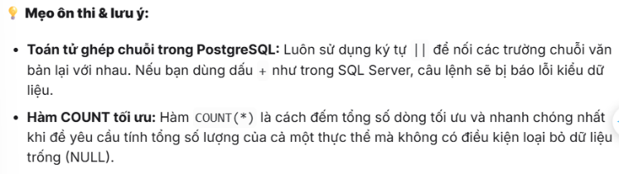  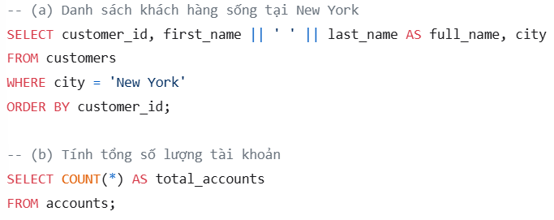  Question 3: Account Balance Analysis (20d)  Dạng bài: Tính tổng có điều kiện lọc (SUM with WHERE) và Gom nhóm dữ liệu kết hợp bảng (Join & Group By).  (a) The Finance Manager wants to monitor funds held in Checking accounts. Calculate their total balance and name the result total_checking_balance. (10 marks)  (b) For each customer living in Los Angeles, display customer_id, full_name, and total_balance across all account types. Sort by total_balance from highest to lowest. (10 marks)  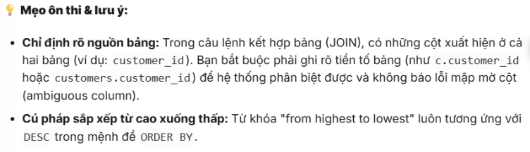  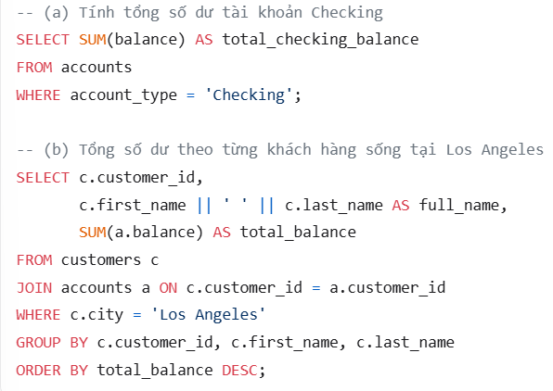  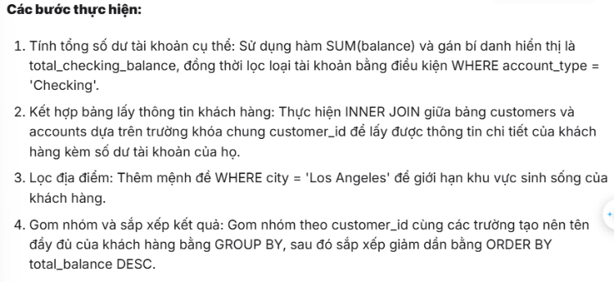

Question 4: Branch and Customer Portfolio Analysis (20d)  Dạng bài: Sử dụng Hàm xếp hạng cửa sổ (Window Function - RANK) để giải quyết bài toán tìm phần tử lớn nhất và xử lý đồng hạng (Ties).  (a) Identify the branch with the highest average account balance. Display branch_id, branch_name, city, and average_balance. Round to two decimal places and include ties. (10 marks)  (b) Identify the customer who owns the single account with the highest current balance. Display customer_id, full_name, account_id, account_type, and balance. Include ties. (10 marks)  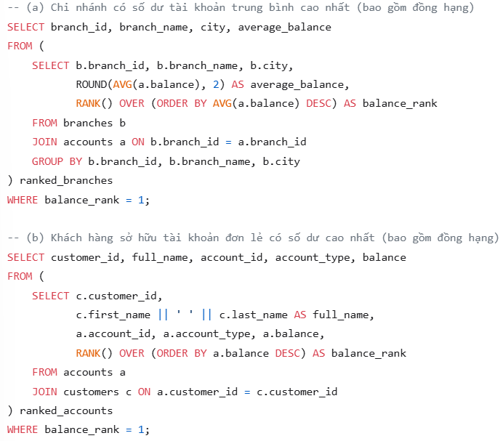  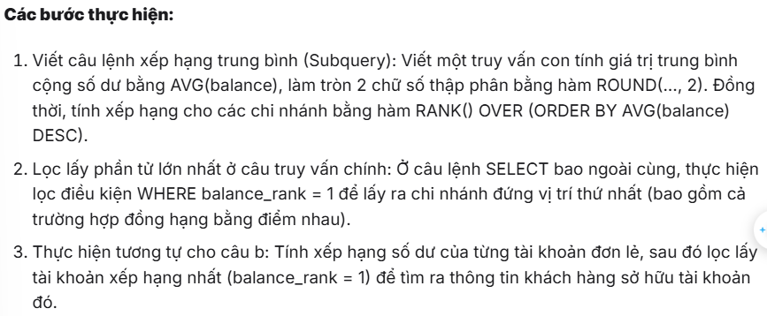   | Question 5: Customer Value and Activity (20d)  Dạng bài: Kết hợp 3 bảng liên tiếp (Multi-table Join) có sử dụng hàm đếm/tổng và xếp hạng cửa sổ xử lý đồng hạng.  (a) Identify the most active customers based on the total number of transactions across all their accounts. Display customer_id, full_name, and total_transactions. Include ties. (10 marks)  (b) Identify the customer with the highest combined balance across Checking and Savings accounts only. Exclude Credit Card accounts. Display customer_id, full_name, and total_deposit_balance. Include ties. (10 marks)  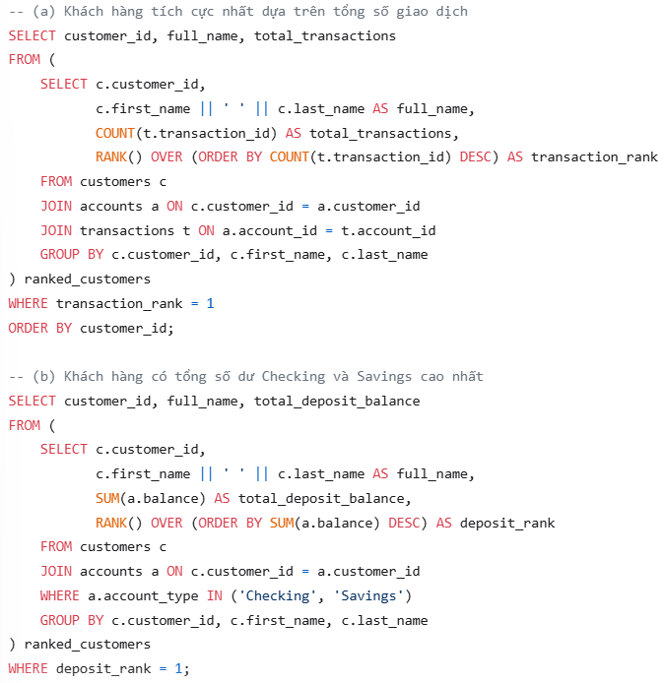  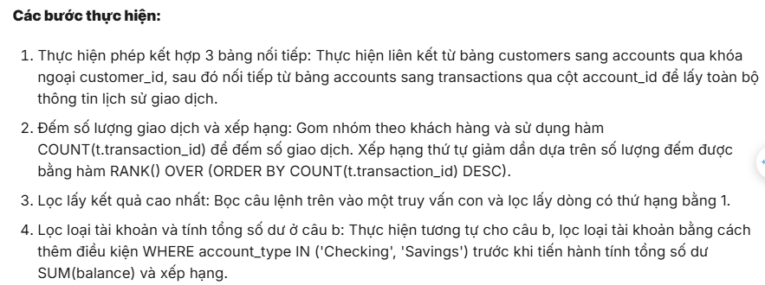  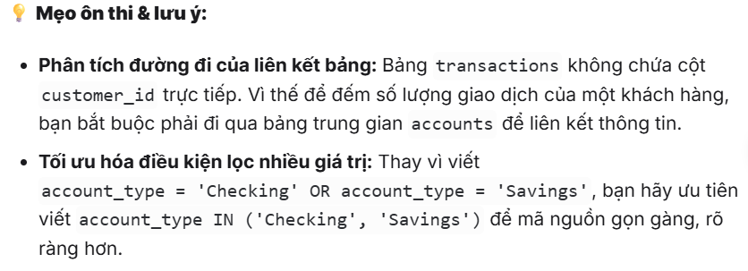

Question 6: Advanced Finance Analysis (20d)  Dạng bài: Tính tổng số dư nhóm theo thực thể, Phân biệt các hàm xếp hạng đồng hạng không nhảy bậc (DENSE_RANK) và Sử dụng bảng tạm thời (CTE) kết hợp hàm đếm bảo toàn dữ liệu bằng LEFT JOIN.  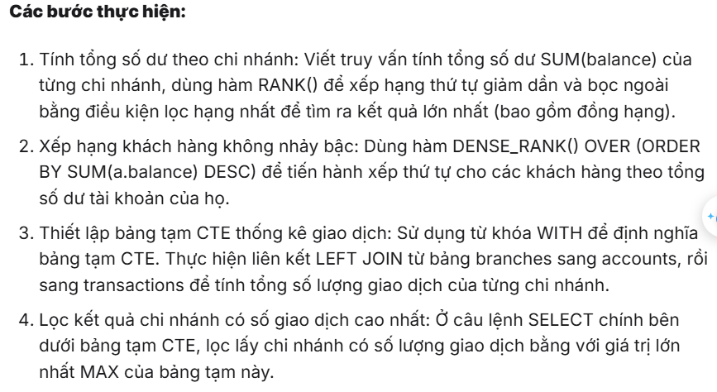  (a) Identify the branch with the highest total balance across all account types. Display branch_id, branch_name, and total_balance. Include ties. (10 marks)  (b) Rank all customers by total balance across all account types. Equal totals must receive the same rank without gaps. Display customer_id, full_name, total_balance, and balance_rank. Do not use a CTE. (5 marks)  (c) Use a CTE to calculate the total number of transactions for every branch, including branches with no transactions. Return the branch or branches with the highest total. Display branch_id, branch_name, and total_transactions. (5 marks)  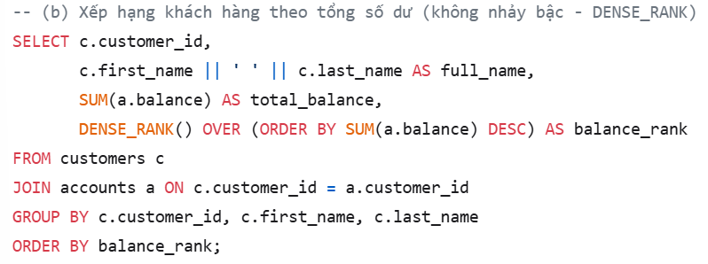  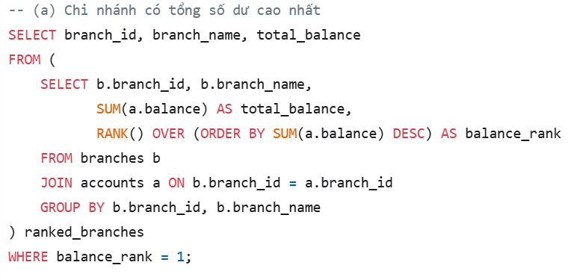 | 